ADS LAB_TEST-1

NAME: MADADI SHIVANI REDDY
ROLL-NO: 2503B05129
BATCH: M.TECH
DEPARTMENT: CSE

Q1. Using the dataset “KNN_regression_dataset.xlsx”, perform the following tasks:
1. Load the dataset and display summary statistics of all features.
2. Split the data into 80% training and 20% testing sets.
3. Standardize/scale the input features appropriately.
4. Build a KNN Regression model with k = 5 to predict Efficiency (%).
5. Use the model to predict the target values for the test set.
6. Calculate and report the following evaluation metrics:
➢ Mean Absolute Error (MAE)
➢ Root Mean Squared Error (RMSE)
➢ R² Score

Executed code:
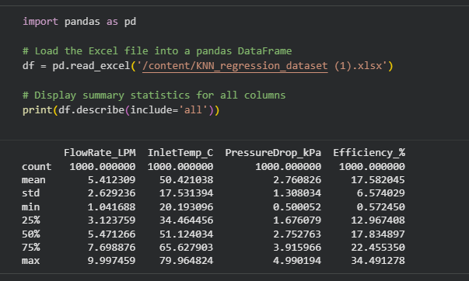

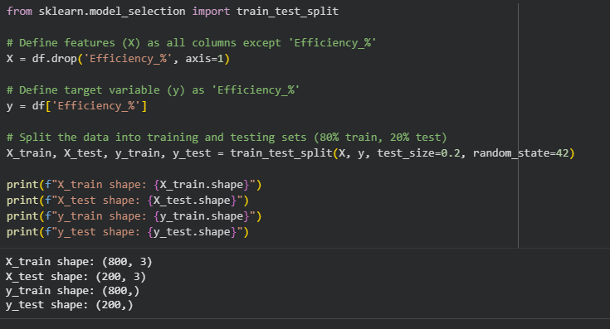

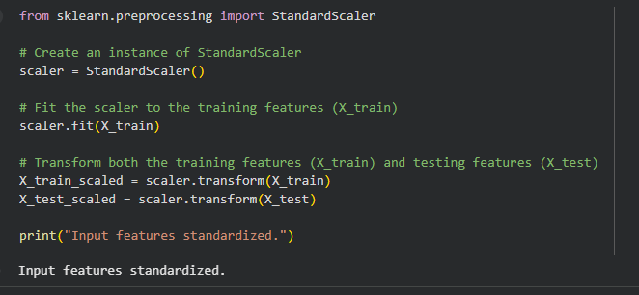
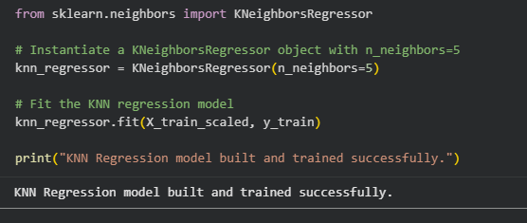

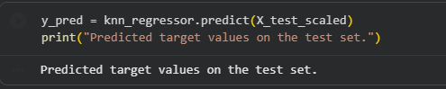

Q2. Study the effect of different k-values on the performance of KNN Regression using
the same dataset.
1. Train four separate KNN Regression models with:
k = 1, 3, 5 and 10
2. For each model, compute and record the R² Score on the test data.
3. Plot a graph of k vs R² Score.
4. Identify which value of k gives the best performance.

Executed code:

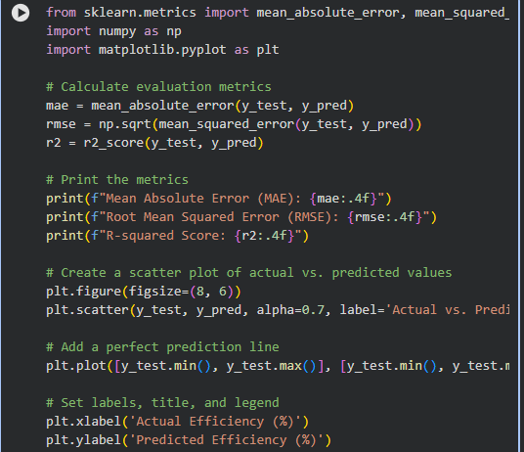
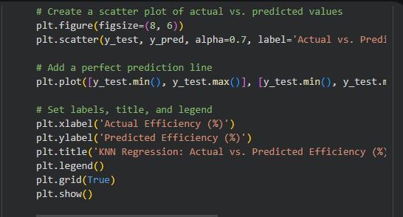

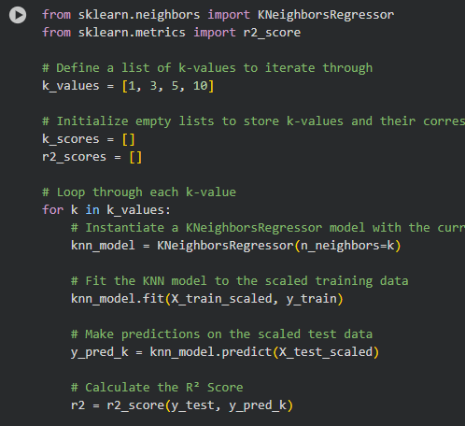

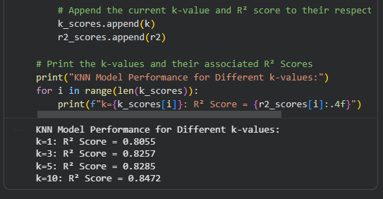
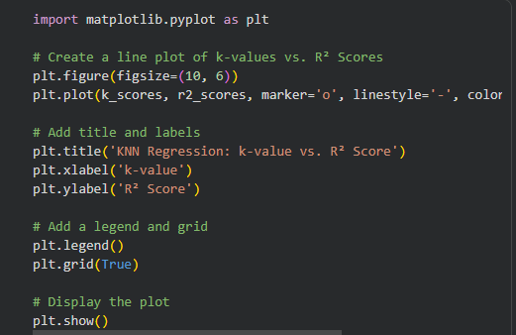

EXPECTED OUTPUT:
